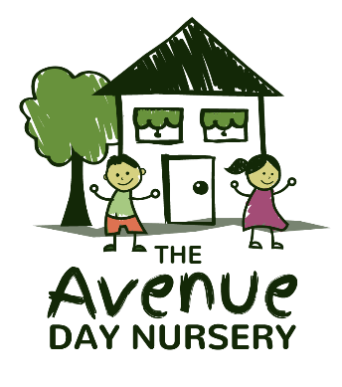**ENQUIRY FORM**

Head Office: Savernake- Unit 4&5 Warren Courtyard, Savernake, SN8 3UU

[Carla@avenue-nursery.co.uk](mailto:Carla@avenue-nursery.co.uk) 01672 870790

Mildenhall- Kennet Barns, Church Lane, Mildenhall, SN8 2LU

[Ewhiting@avenue-nursery.co.uk](mailto:Ewhiting@avenue-nursery.co.uk) 01672 515763

Aldbourne- Smith’s Barn, West Street, Aldbourne, SN8 2BS

[Sam@avenue-nursery.co.uk](mailto:Sam@avenue-nursery.co.uk%2001672)  01672 541730

**CHILDS DETAILS** Boy 🞏 Girl 🞏 Gender Unknown 🞏

Child’s full name: __________________________________________________________________________________

Known as: ______________________________________ EDD / Date of Birth: _____________________________

First Language: _________________________________ Other languages:_______________________________

**PARENT / GUARDIAN DETAILS**

PARENT / GUARDIAN PARENT / GUARDIAN

Full name: ____________________________________ Full name: ____________________________________

Salutation: Mr Mrs MS Dr Other _________________ Salutation: Mr Mrs MS Dr Other _________________

Address: _____________________________________ Address: _____________________________________

_______________________________________________ _______________________________________________

_______________________________________________ _______________________________________________

_______________________________________________ _______________________________________________

Telephone Numbers

Home: _______________________________________ Home: _______________________________________

Work: ________________________________________ Work: _______________________________________

Mobile: _______________________________________ Mobile: _______________________________________

Email Address: ________________________________ Email Address: ________________________________

**Preferred start date: ___________________ Full time/Term time**

|  |  |  |  |  |
| --- | --- | --- | --- | --- |
| *Days* | **Morning**  **(08:00 – 13:00)** | **Afternoon**  **(13:00 – 18:00)** | **School Day**  **(09:00 – 15:00)** | **Full Day**  **(08:00 – 18:00)** |
| *Monday* |  |  |  |  |
| *Tuesday* |  |  |  |  |
| *Wednesday* |  |  |  |  |
| *Thursday* |  |  |  |  |
| *Friday* |  |  |  |  |

**WHERE DID YOU HEAR ABOUT US?**

|  |  |  |  |
| --- | --- | --- | --- |
| Recommendation |  | Net mums website |  |
| Word of mouth |  | Day Nurseries.co.uk website |  |
| Internet Search |  | Advertisement – say where |  |
| Website |  | Other – please tell us |  |